LABORATORIYA ISHI №10

Mavzu: Bootstrap yordamida adaptiv sahifa yaratish

Ishdan maqsad
Talabalarda Bootstrap frameworkidan foydalanib, turli qurilmalarga moslashuvchi (responsive) veb sahifa yaratish ko‘nikmalarini shakllantirish.
Nazariy qism
Bootstrap nima?
Bootstrap — bu HTML, CSS va JavaScript asosida yaratilgan ochiq kodli frontend framework bo‘lib, tez va qulay tarzda zamonaviy veb sahifalar yaratishga yordam beradi.

Adaptiv dizayn (Responsive design)
Adaptiv dizayn — bu veb sahifaning:
- telefon 📱
- planshet 📱
- kompyuter 💻
kabi turli ekran o‘lchamlariga moslashishidir.

Bootstrap grid tizimi
Bootstrap 12 ustundan iborat grid tizimdan foydalanadi:
- .col- — kichik ekranlar
- .col-sm-
- .col-md-
- .col-lg-
- .col-xl-

Bootstrap grid misollari
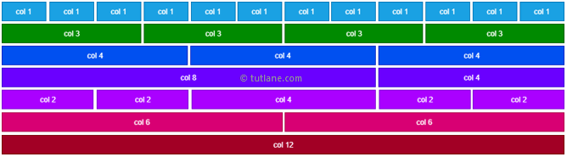
Kerakli vositalar
- Matn muharriri (VS Code yoki boshqa)
- Brauzer (Chrome, Firefox)
- Internet (Bootstrap CDN uchun)

Amaliy misollar

1-Misol: Bootstrap ulash
Quyidagi kod orqali Bootstrap CDN ni ulang:
<!DOCTYPE html>
<html lang="uz">
<head>
<meta charset="UTF-8">
<meta name="viewport" content="width=device-width, initial-scale=1.0">
<title>Bootstrap sahifa</title>
<link href="https://cdn.jsdelivr.net/npm/bootstrap@5.3.0/dist/css/bootstrap.min.css" rel="stylesheet">
</head>
<body>
</body>
</html>

2-misol: Navbar yaratish
<nav class="navbar navbar-expand-lg navbar-dark bg-dark">
<div class="container">
<a class="navbar-brand" href="#">Mening sayt</a>
</div>
</nav>
3-misol: Grid tizimdan foydalanish
<div class="container mt-4">
<div class="row">
<div class="col-md-4 bg-primary text-white p-3">1-blok</div>
<div class="col-md-4 bg-success text-white p-3">2-blok</div>
<div class="col-md-4 bg-danger text-white p-3">3-blok</div>
</div>
</div>

4-misol: Kartalar (Cards) qo‘shish
<div class="container mt-4">
<div class="row">
<div class="col-md-4">
<div class="card">
<div class="card-body">
<h5 class="card-title">Sarlavha</h5>
<p class="card-text">Matn joylashadi</p>
</div>
</div>
</div>
</div>
</div>

5-topshiriq: Adaptivlikni tekshirish
- Brauzerni kichraytirib ko‘ring
- Developer tools (F12) orqali turli qurilmalarda sinab ko‘ring

Hisobot tarkibi
Talaba quyidagilarni topshirishi kerak:
- Ish mavzusi
- Ishdan maqsad
- Nazariy qism
- Dastur kodi
- Natija (skrinshotlar bilan)
- Xulosa
Topshiriq:

22. Portfolio sayt
To‘liq kichik sayt yarating:
- O‘zingiz haqida
- Ishlaringiz (portfolio)
- Aloqa formasi
- Responsive dizayn

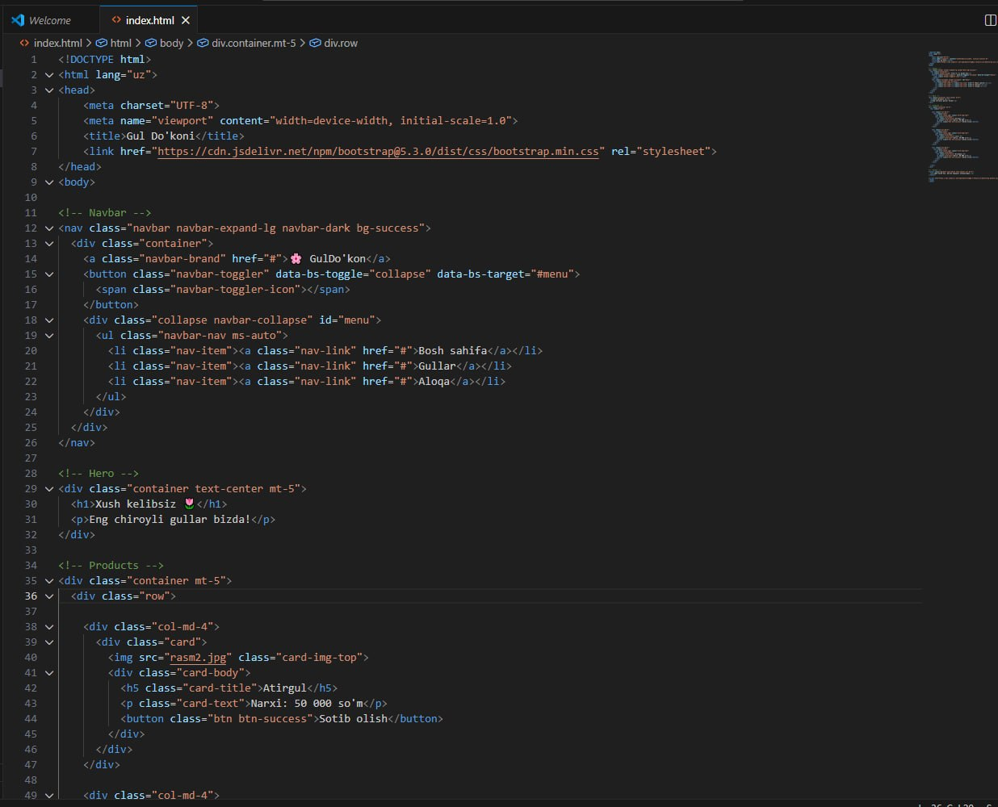
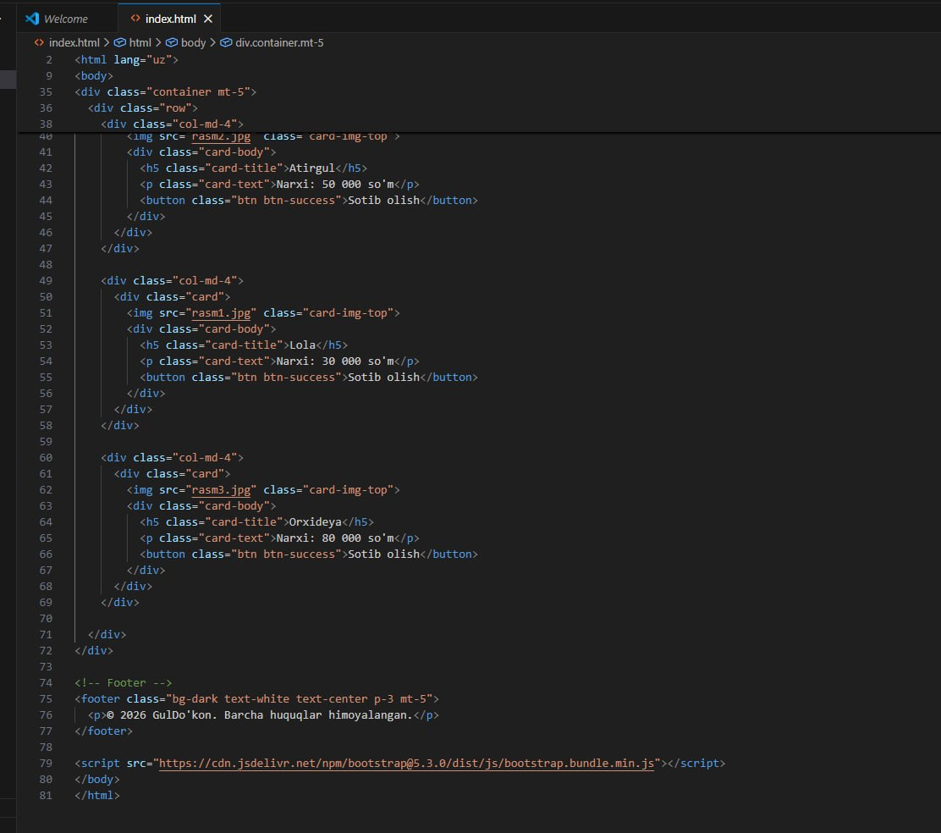
NATIJA:
